**1. Install**

Double-click DaliMaster V1.106 2025070816 x64.exe to install the software.

**2. Open Localization Configuration**

After launching the software, follow the menu steps shown below to access the localization configuration:

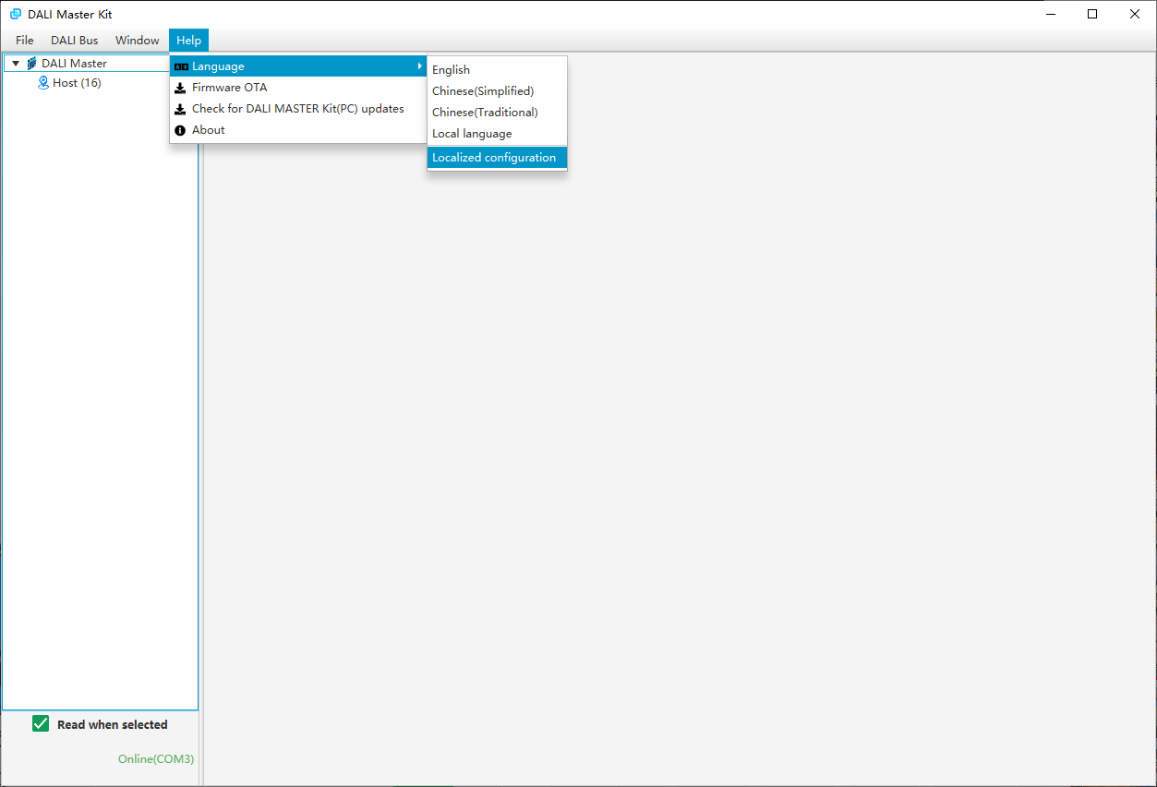

图形用户界面, 文本, 应用程序, 电子邮件

AI 生成的内容可能不正确。

**3. Language Resource Entry**

You can complete language entries in two ways: Batch import using an Excel file; Double-click each row in the list to edit and submit translations one by one.

**Note:** To import via Excel, click “Template Download” to get the template. Enter translations in the “Custom Language” column based on the English reference. Once done, go to the “Localization Configuration” window and click “Import Language” to upload the file. The software will check for missing or duplicate entries. If prompted about missing entries, see Step 4 for details (red text).

**4. Custom Language Resource Supplementation**

**Skip this step if no custom Excel resource file is used.**

Click “Import Language”, select your completed file, and the system will begin initializing the local language resources. A pop-up will display the results after initialization.

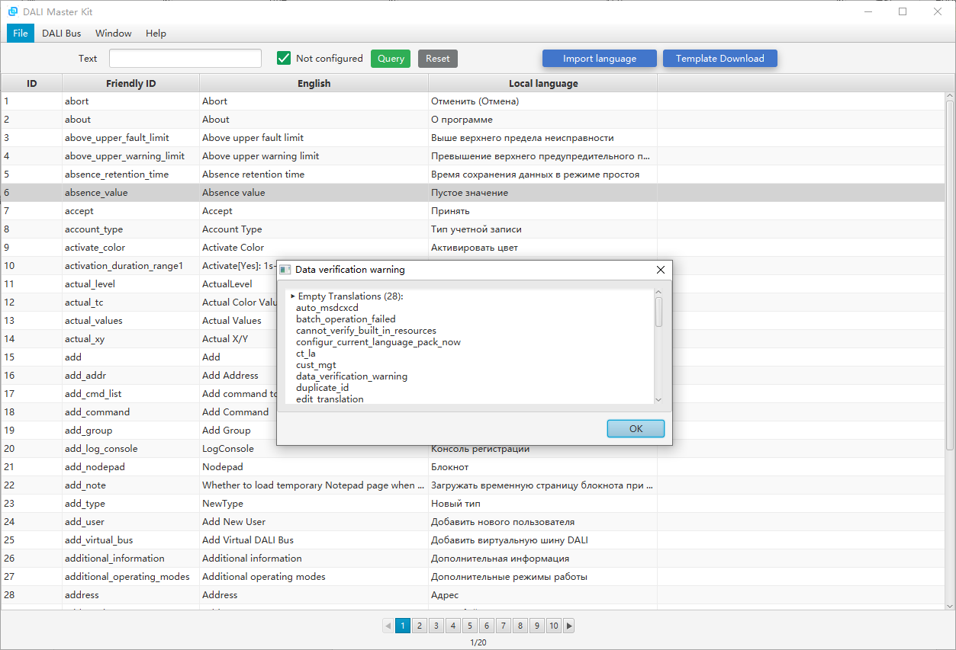

For example, the pop-up shown above indicates 28 empty translations (due to newer content in the software not covered in the earlier customer file). **To fix this: Select “Not Configured”, click “Query” to list all missing items, double-click a target row to edit the “Local Language” field, and fill in translations one by one to complete localization.**

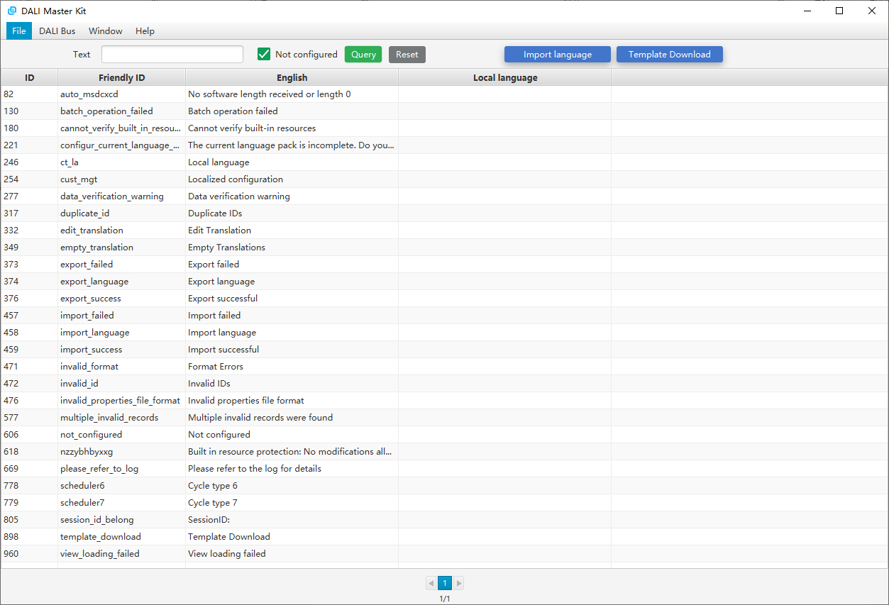

**5. Backup**

After finishing all translations, click the “Template Download” button again to download the Excel file that now includes your localized data. Keep this file safe. This is important because localization files are stored in the installation directory. If lost or deleted, you can re-import this Excel file (repeat Step 3) to recover your translations without re-entering them.

**6. Back to Home Window**

Click “Home” under the “Window” menu to return to the main interface.

